### Movie Ticketing Bot

Category: IBM Cloud Application

**Project Description:**

In this project, we will be building a chatbot using Watson assistant. This chat should have the following capabilities:

1. Give the list of movies available
2. The Bot should be able to show different show timings
3. When a movie is selected the bot should show the availability of tickets and their respective prices.
4. The bot should be in a position to book tickets.

**Services Used:**

1. IBM Watson Assistant
2. Node-Red

### Create Intents

Duration: 0.5 Hrs

Skill Tags: WAS

Create intents for the movie ticket booking chatbot, You can add the following intents:

1. Greetings
2. Movies availability
3. Book tickets
4. Inquiry

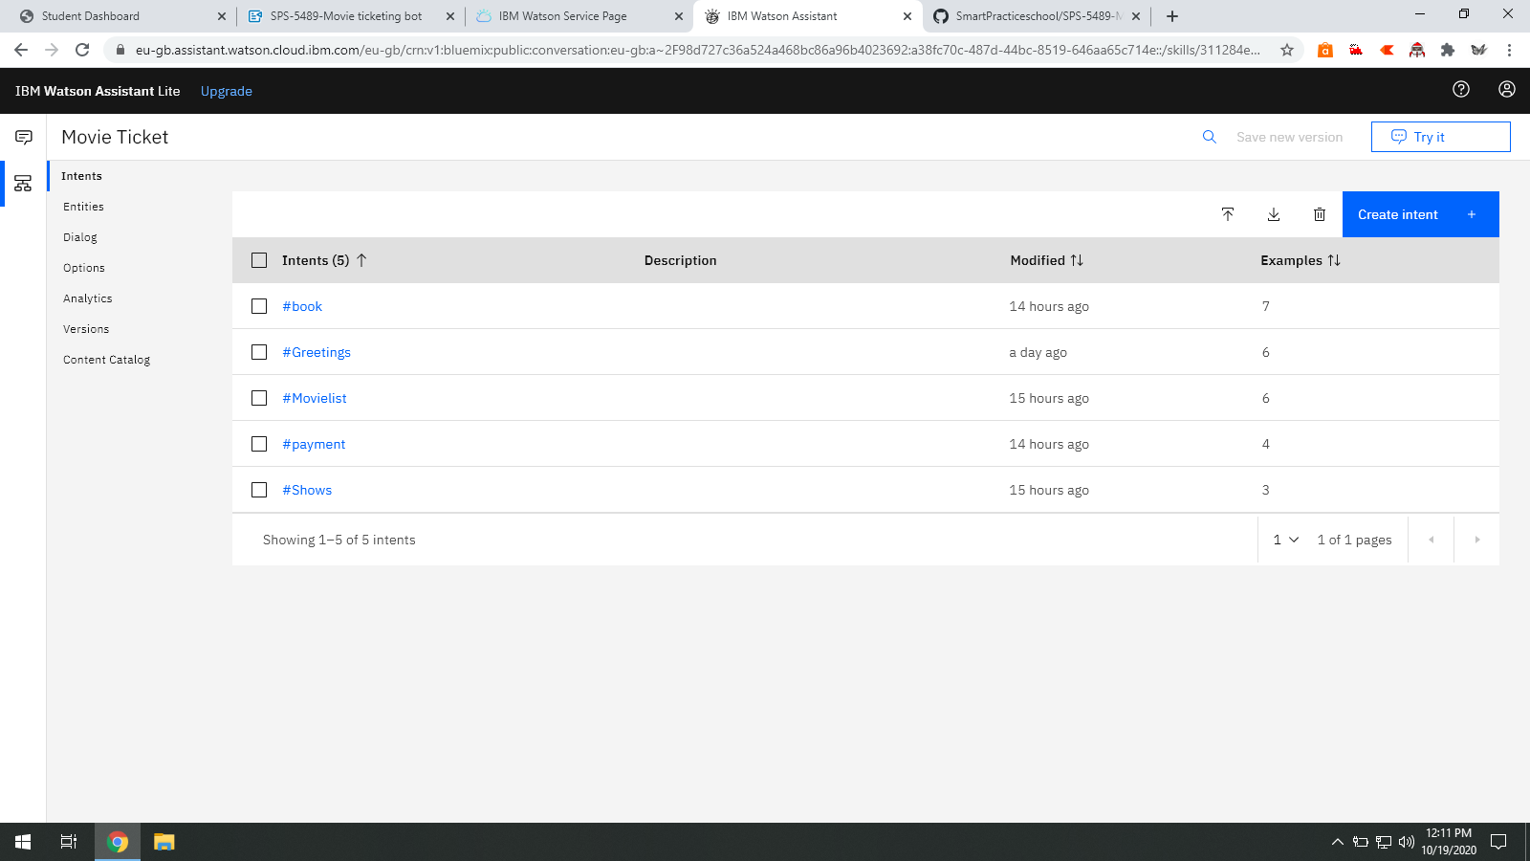

### Create Entities

Duration: 0.5 Hrs

Skill Tags: WAS

In this activity, you need to create entities that include all the keywords that are present in the respective intents. Create multiple entities according to the requirement of the chatbot.

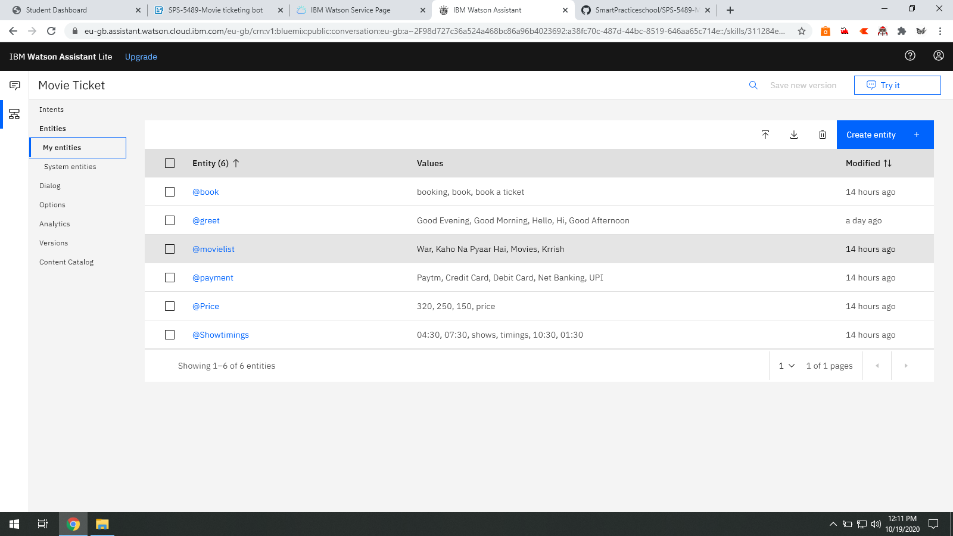

### Create Dialog

Duration: 2 Hrs

Skill Tags: WAS

In this activity, we will be using Dialog in the Watson assistant to respond to the user.

In this chatbot add nodes for Greetings, inquiry, availability of movies, Booking of tickets. In booking tickets, you can make use of slots.

Make sure to delete context variables to make the chatbot reusable to other users.

Try to extract email id from the user by using patterns in entities.

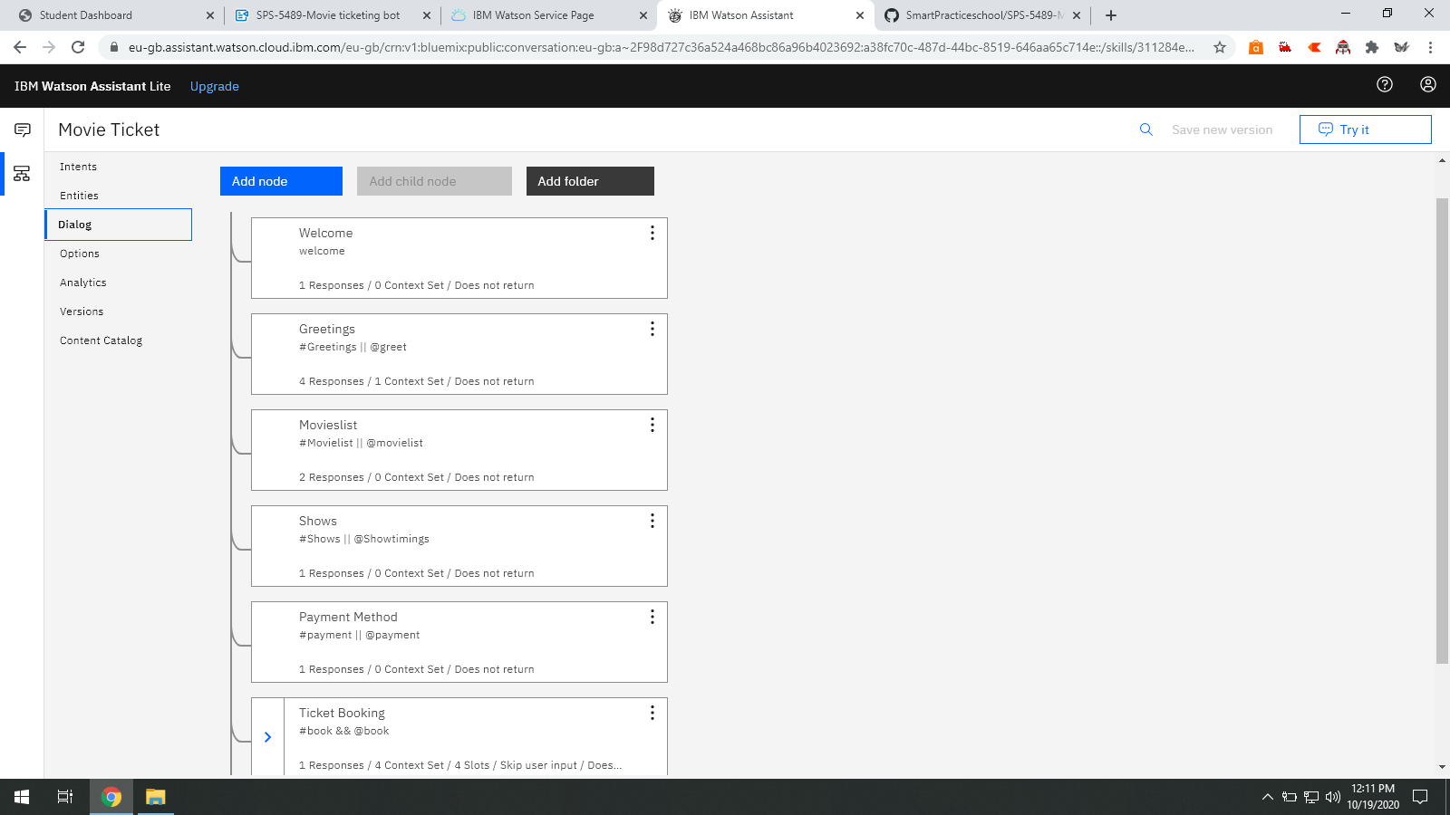

### Create Node-Red Service

Duration: 0.5 Hrs

Skill Tags: WAS

Firstly to use node-red we need to create node-red service by going to the catalog.If you already have node-red service in your IBM cloud You can directly go to node-red from your dashboard by going to cloud foundry apps.

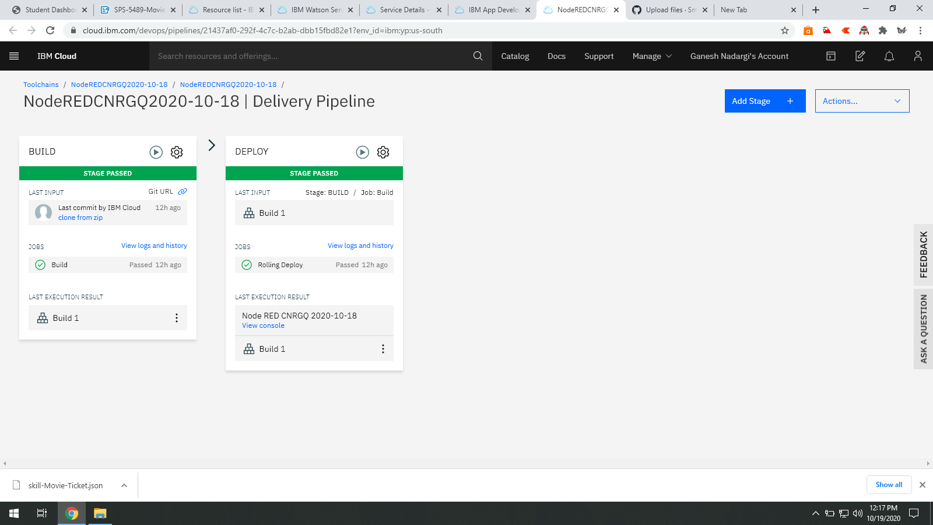

### Integrate Node Red To Watson Assistant

Duration: 0.5 Hrs

Skill Tags: WAS

In this activity, you will be integrating node-red to Watson assistant by using an assistant node in node-red.

* Firstly configure the assistant node by giving API key and service endpoint which you get from the skill that was created in Watson assistant.
* Next install the dashboard nodes from the manage pallete and create UI accordingly by making use of form nodes and text nodes.

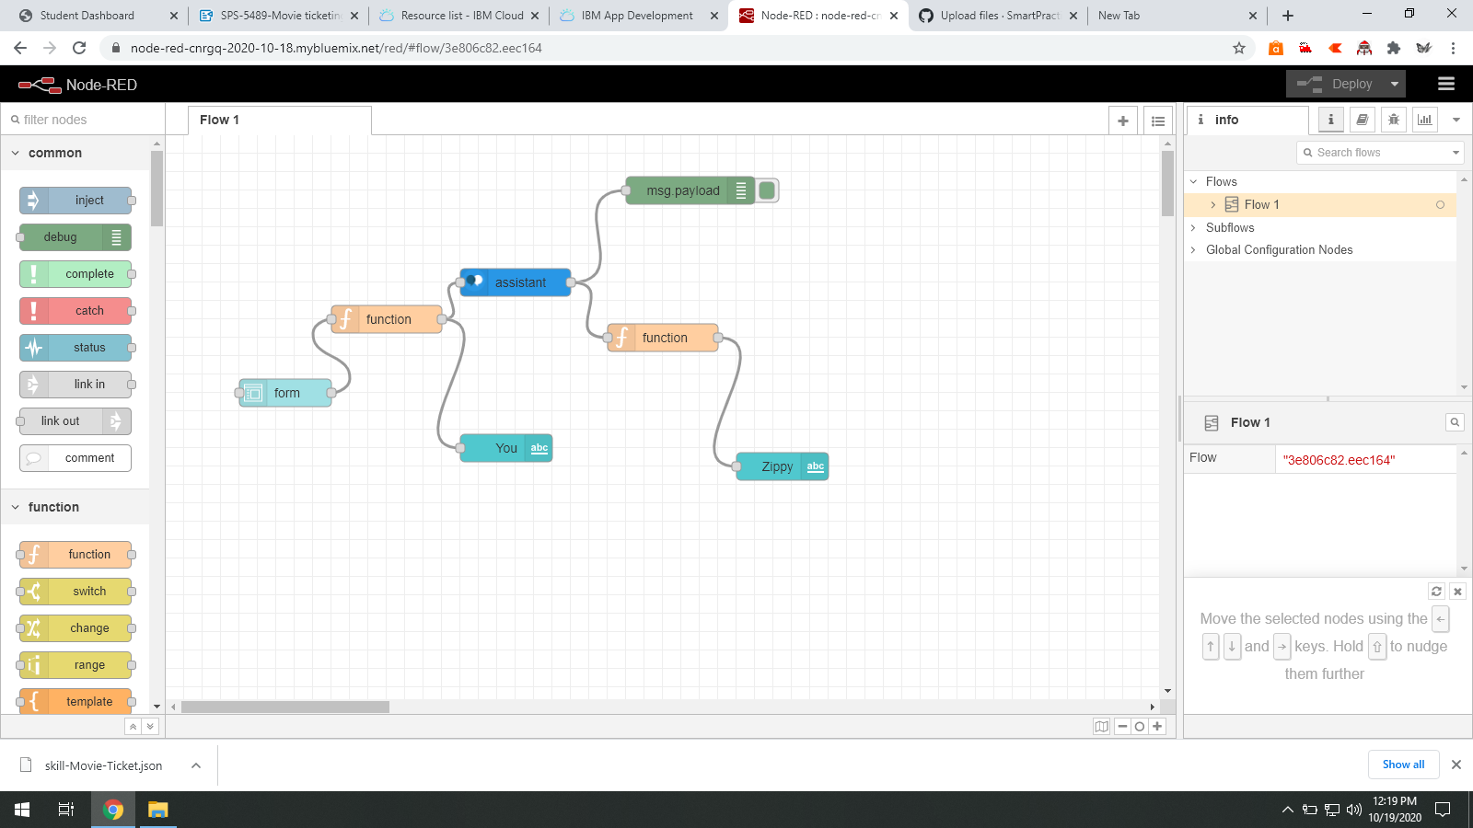

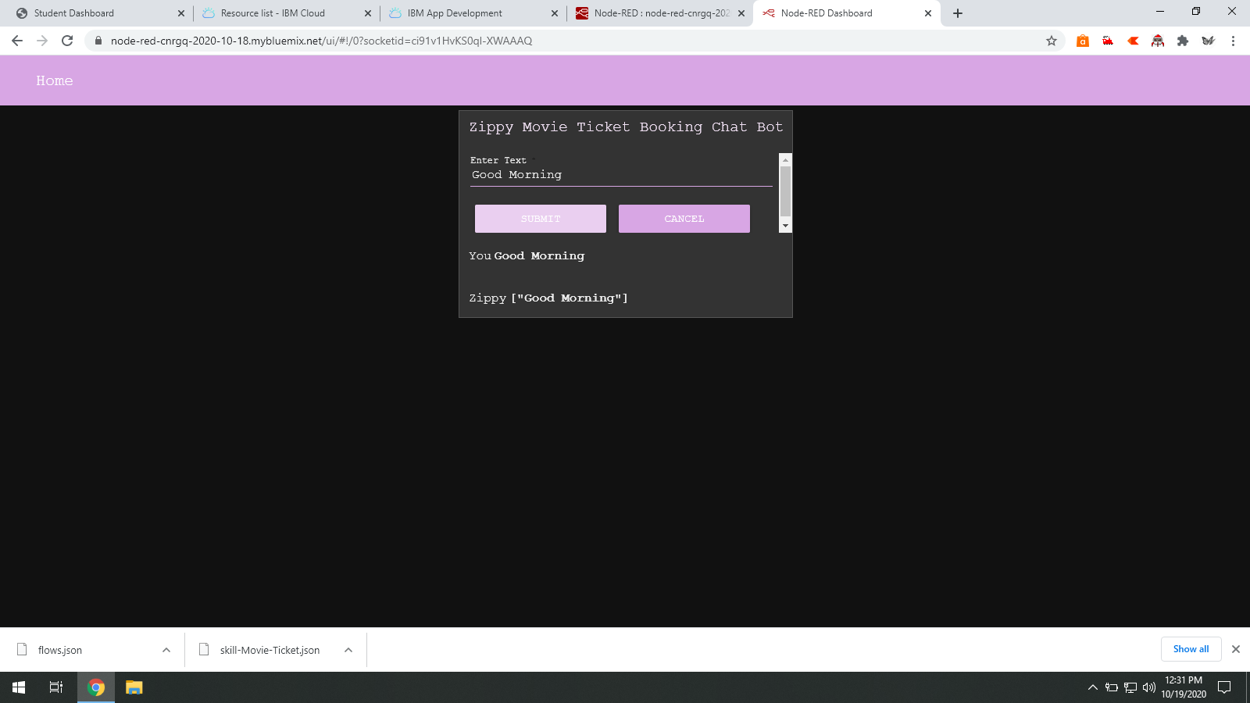

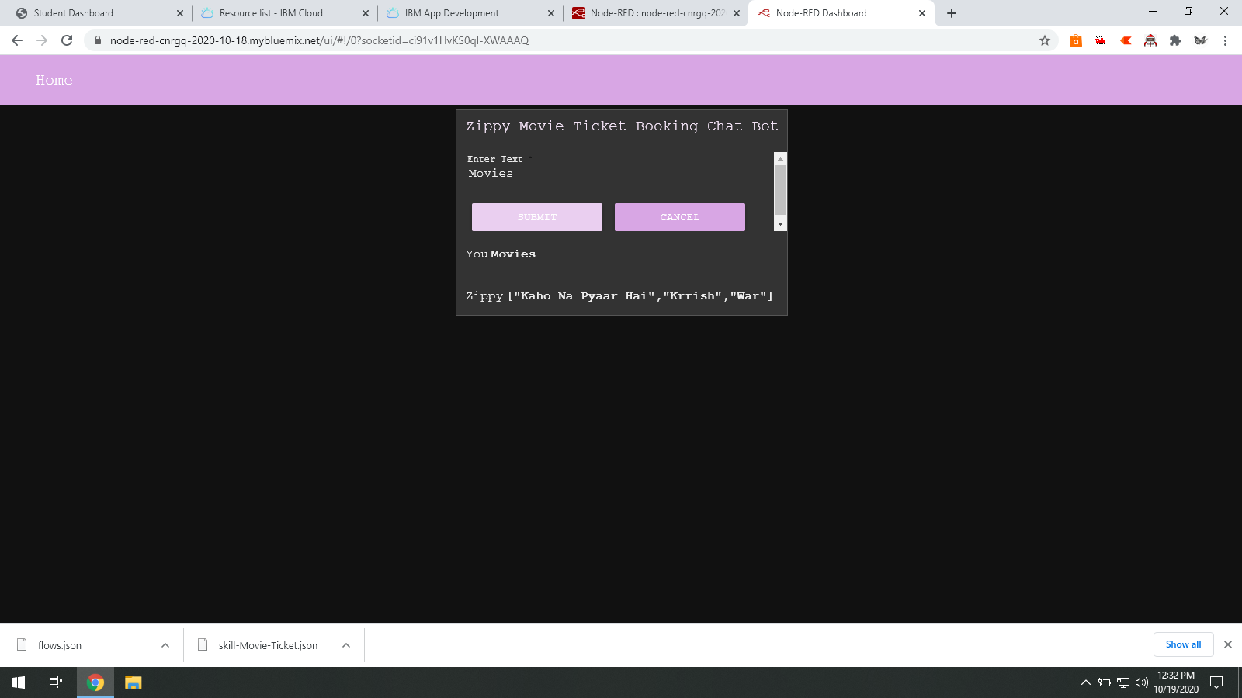

Link for Node Red App: https://node-red-cnrgq-2020-10-18.mybluemix.net/ui

**Conclusion**

Learnt Basics about IBM Watson Assistant and Node Red. The Project as interesting and innovative which helped in understanding how the Chat Bots work